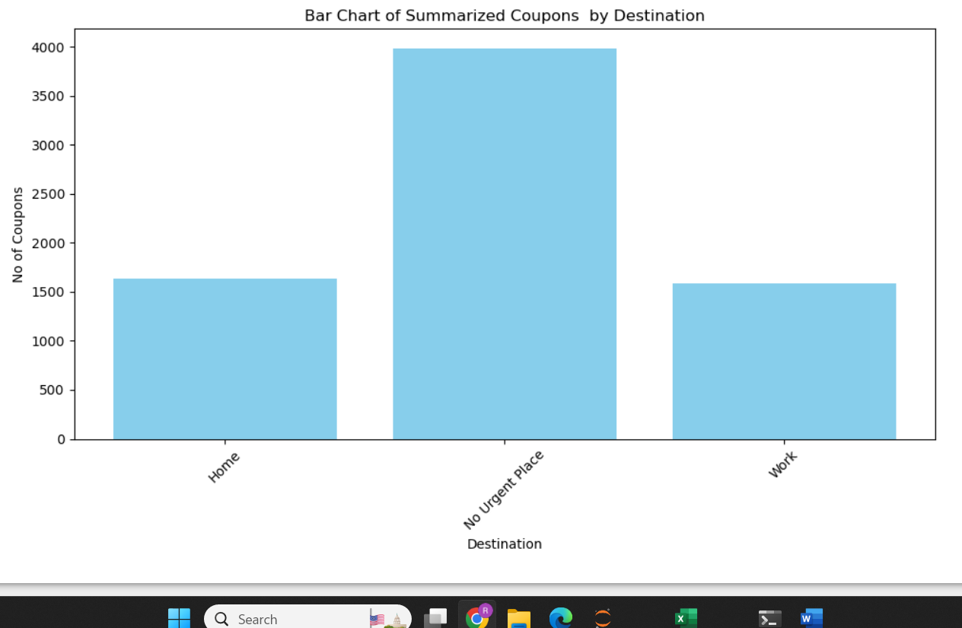

**Findings**

Based on the available data for Destination , there is no direct correlation between Destination and acceptance of Coupons. The predominant Destination seems to be ‘No Urgent Place’ which seems to be an undefined destination.

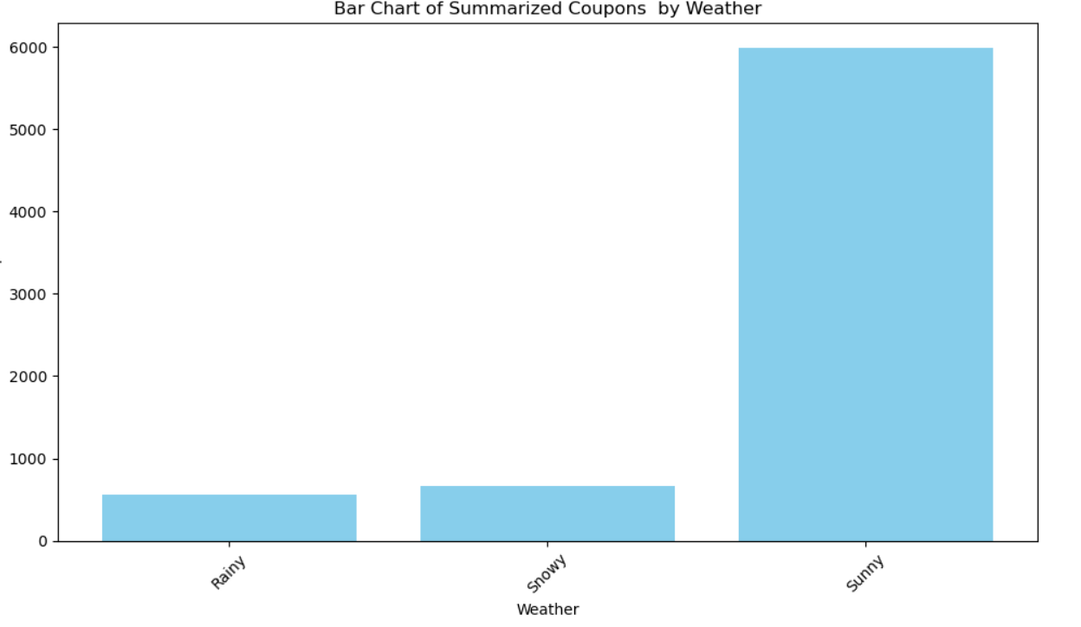

**Findings**

Based on the available data for Weather , the sunny weather seems to be favorable for acceptance of coupons.

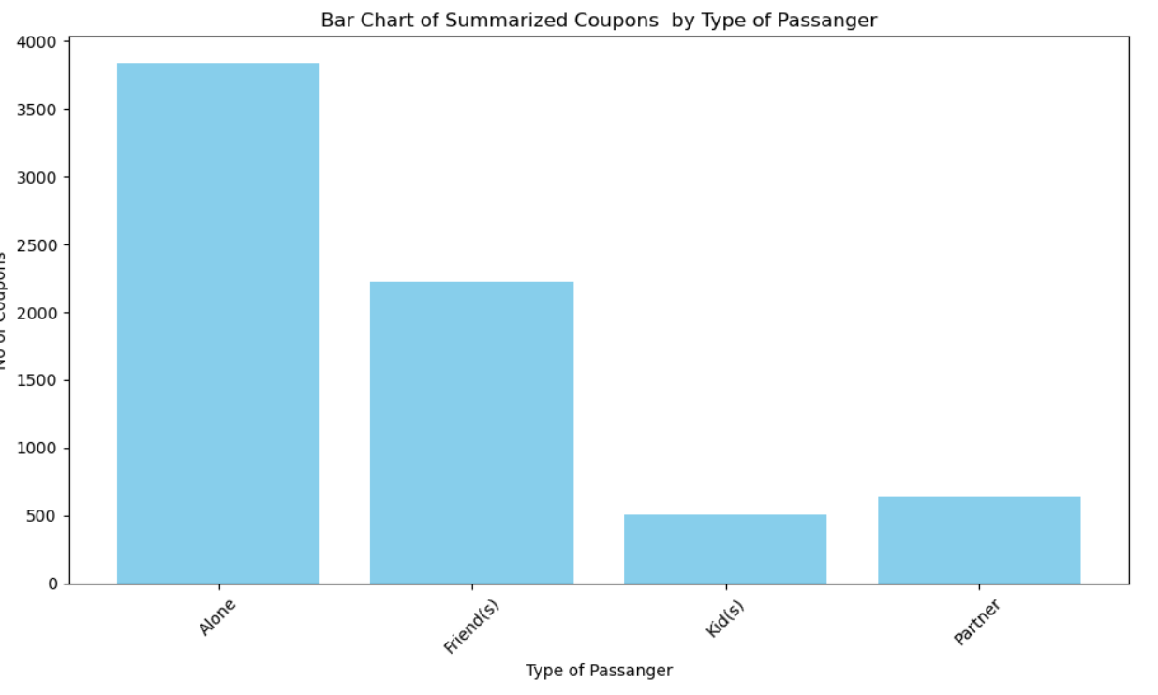

**Findings**

Based on the available data for Type of Passenger , Passengers travelling alone seems to be favorable for acceptance of coupons.

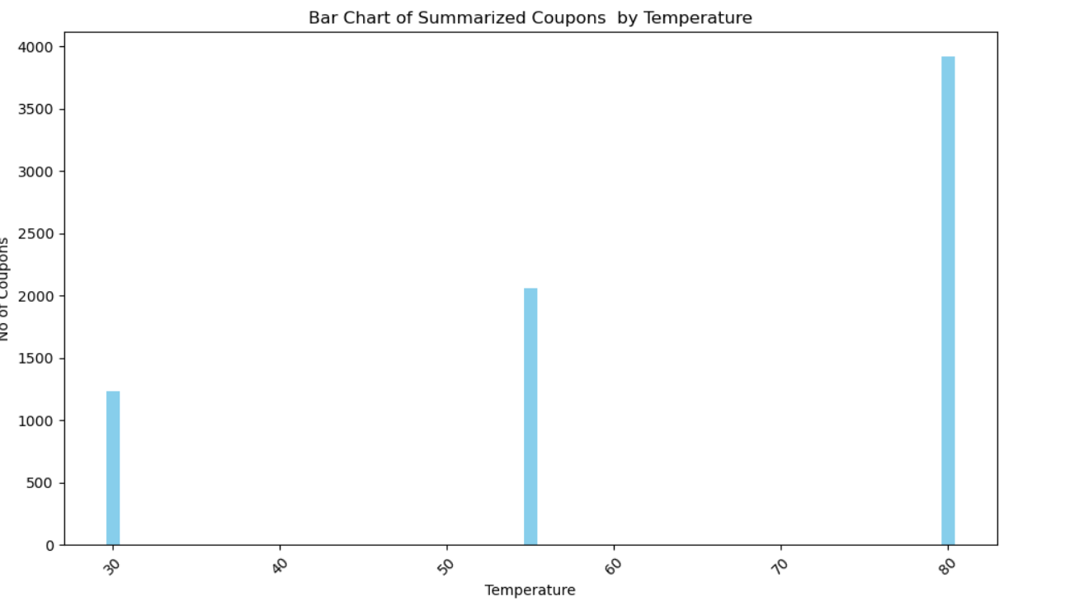

**Findings**

Based on the available data for Temperature , the higher temperatures seems to be favorable for acceptance of coupons.

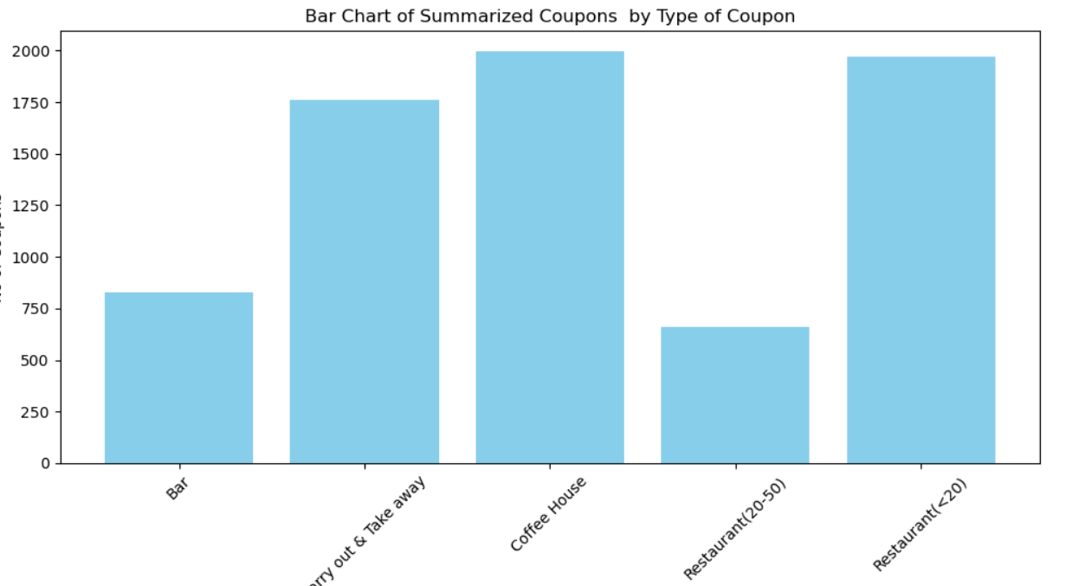

**Findings**

Based on the available data for Type of Coupons , the Coffee House and Restaurant with capacity of less than 20 seems to be favorable for acceptance of coupons.

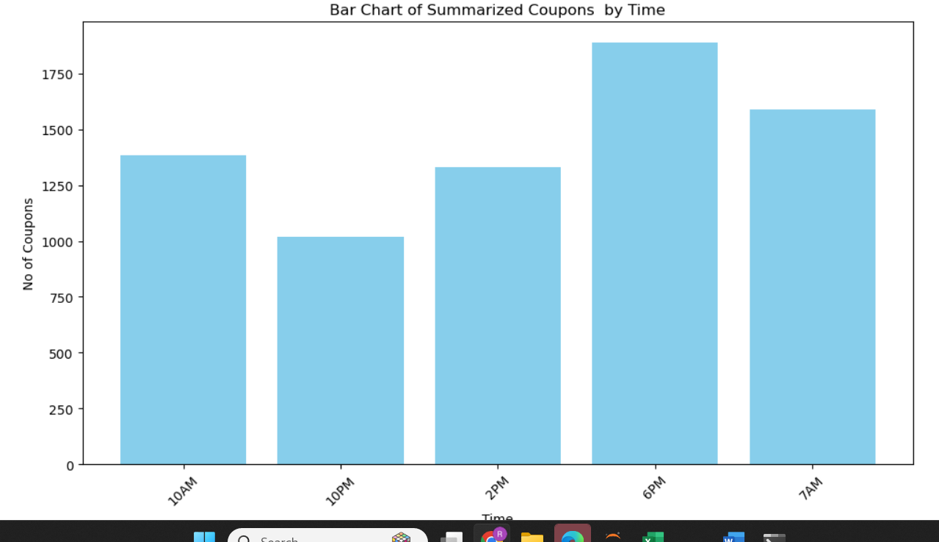

**Findings**

Based on the available data for Time, Late evening or early morning seems to be favorable for acceptance of coupons.

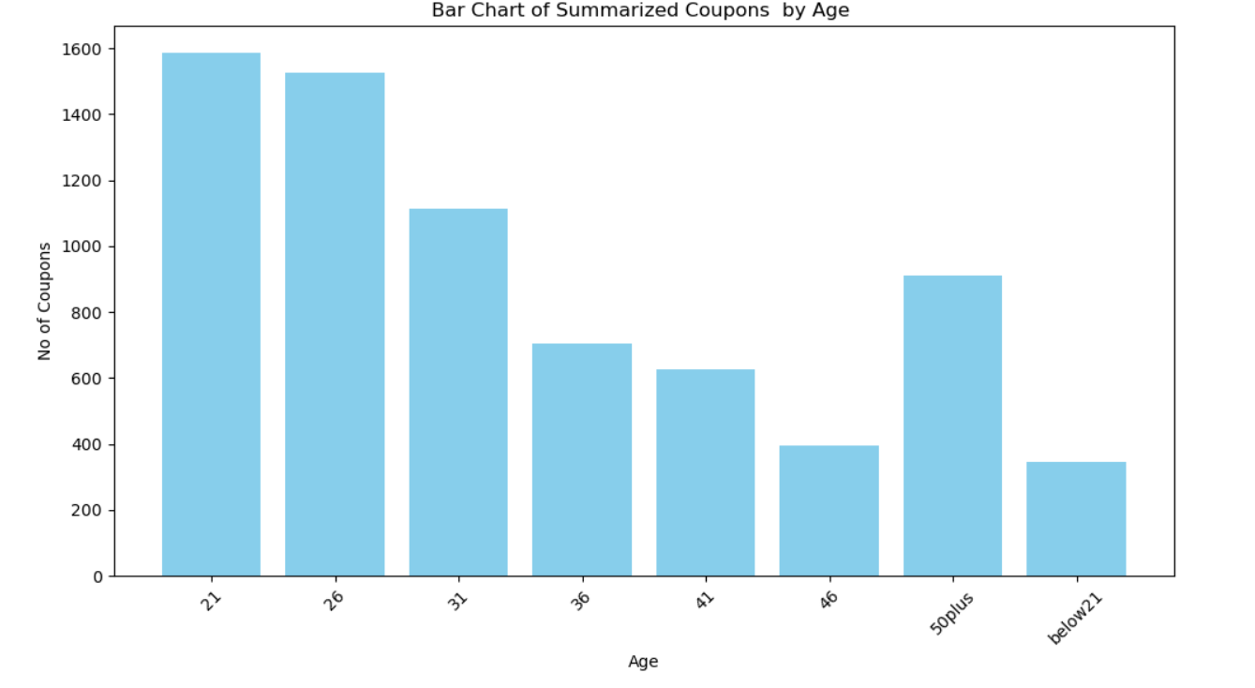

**Findings**

Based on the available data for age, 21,26 and 31 seems to be favorable for acceptance of coupons.

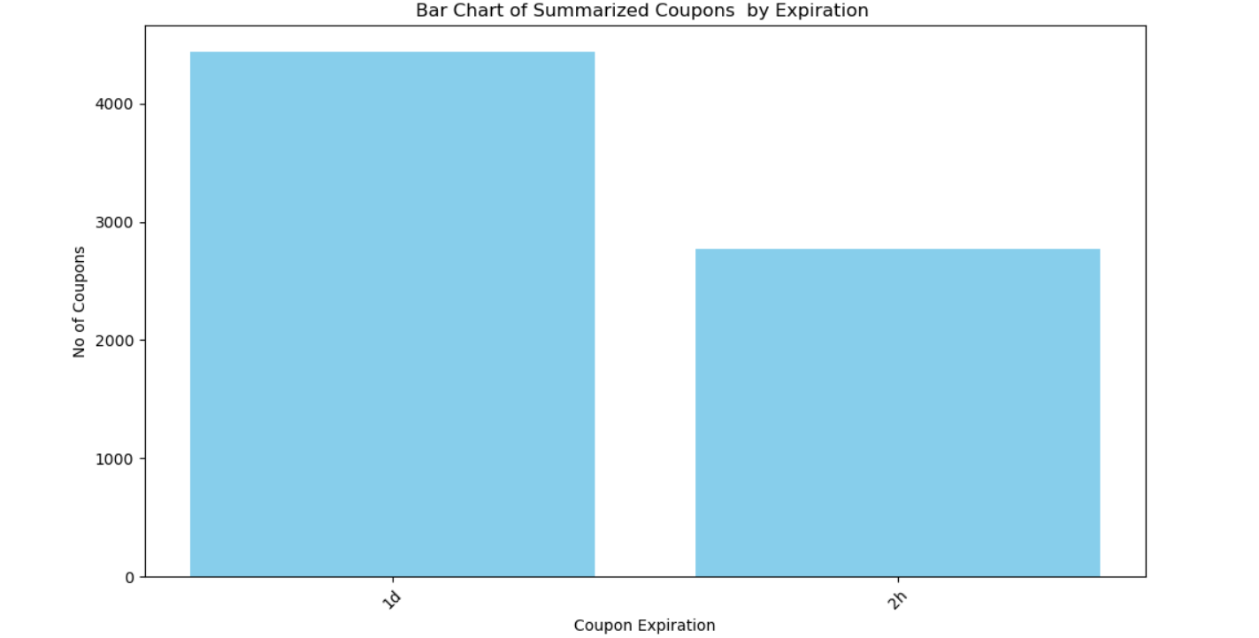

**Findings**

Based on the available data for Coupons ExpiryCoupons expiring in 1 day seems to be favorable for acceptance of coupons.

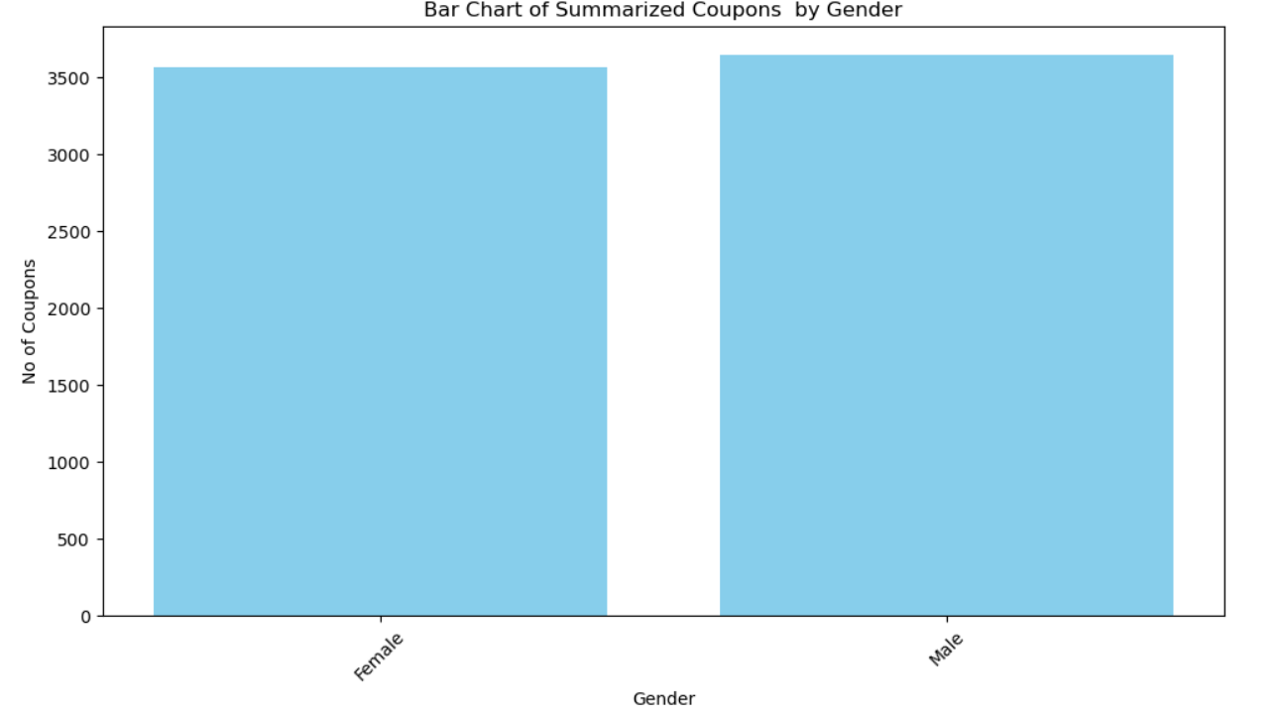

**Findings**

Based on the available data for Gender , Male and Female members seem to have the same disposition for acceptance of coupons.

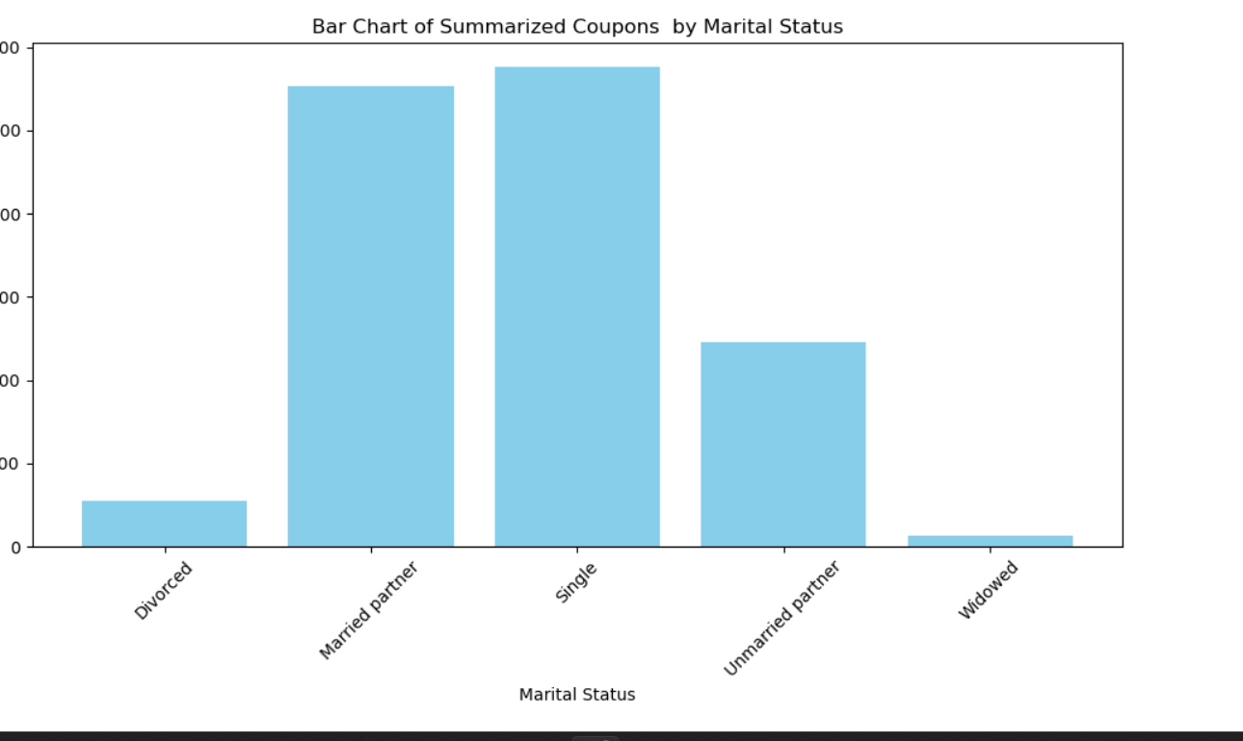

**Findings**

Based on the available data for Marital Status , Single and Married Partner members seem to have more disposition for acceptance of coupons.

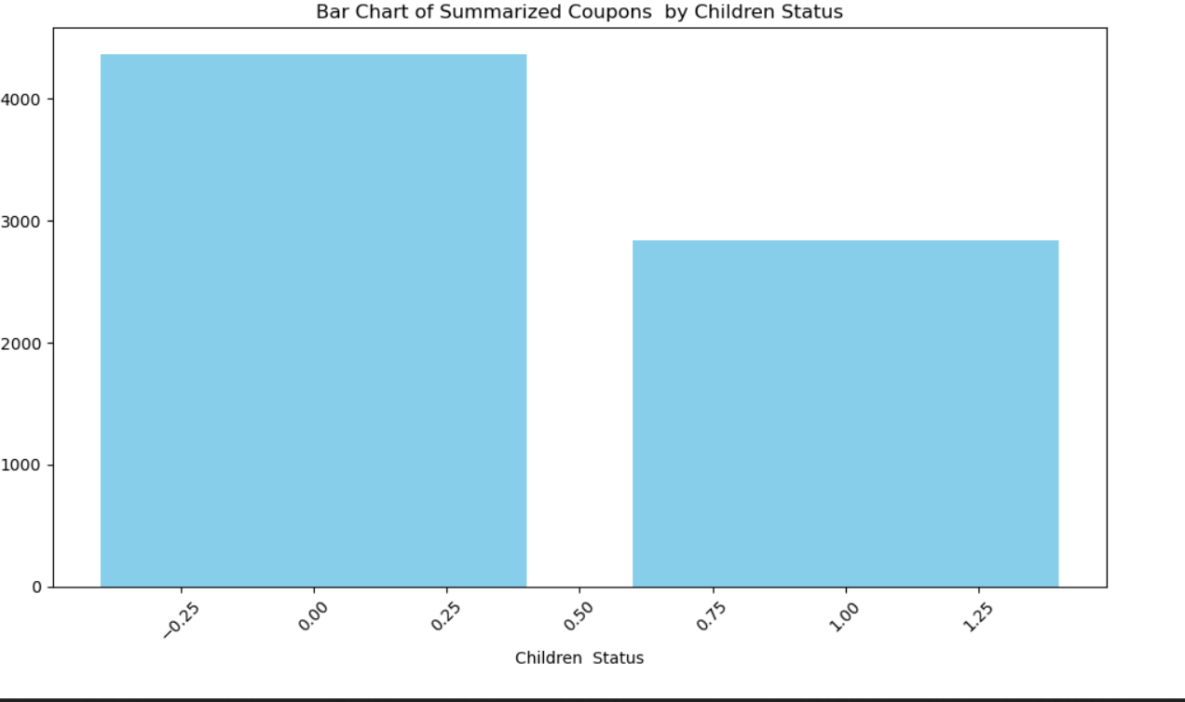

**Findings**

Based on the available data for Number of Children , members with no children seem to have more disposition for acceptance of coupons.

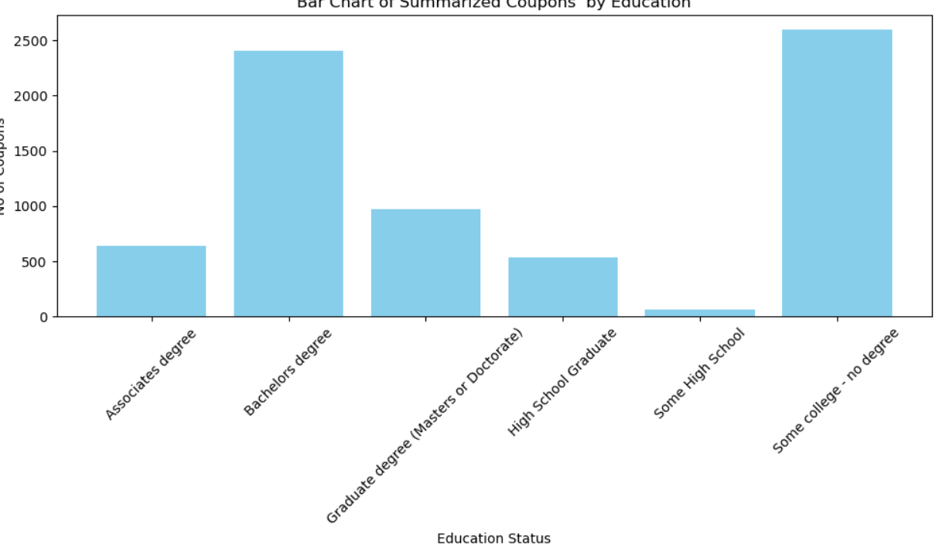

**Findings**

Based on the available data for Education , members with Bachelor’s degree or Some College / No Degree seem to have more disposition for acceptance of coupons.

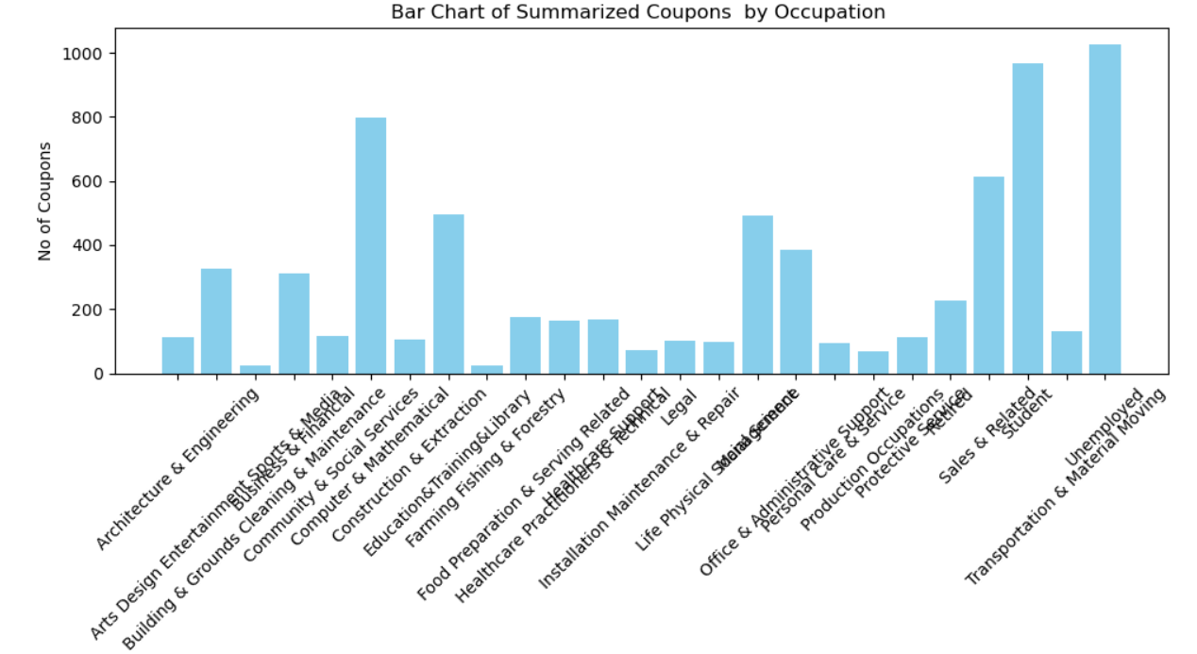

**Findings**

Based on the available data for Occupation , members who are **Unemployed** seem to have more disposition for acceptance of coupons.

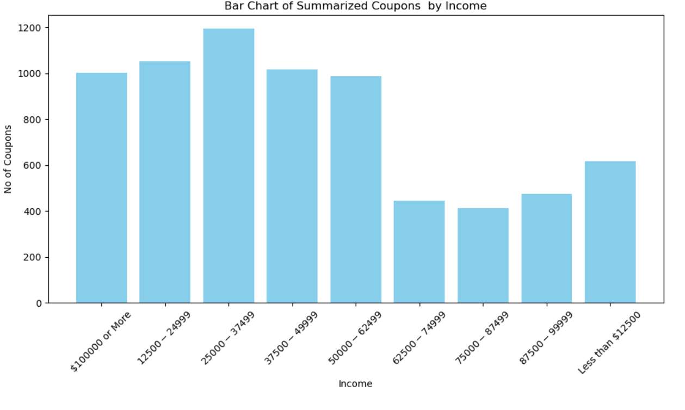

**Findings**

Based on the available data for Income , members who with higher incomes seem to have more disposition for acceptance of coupons.

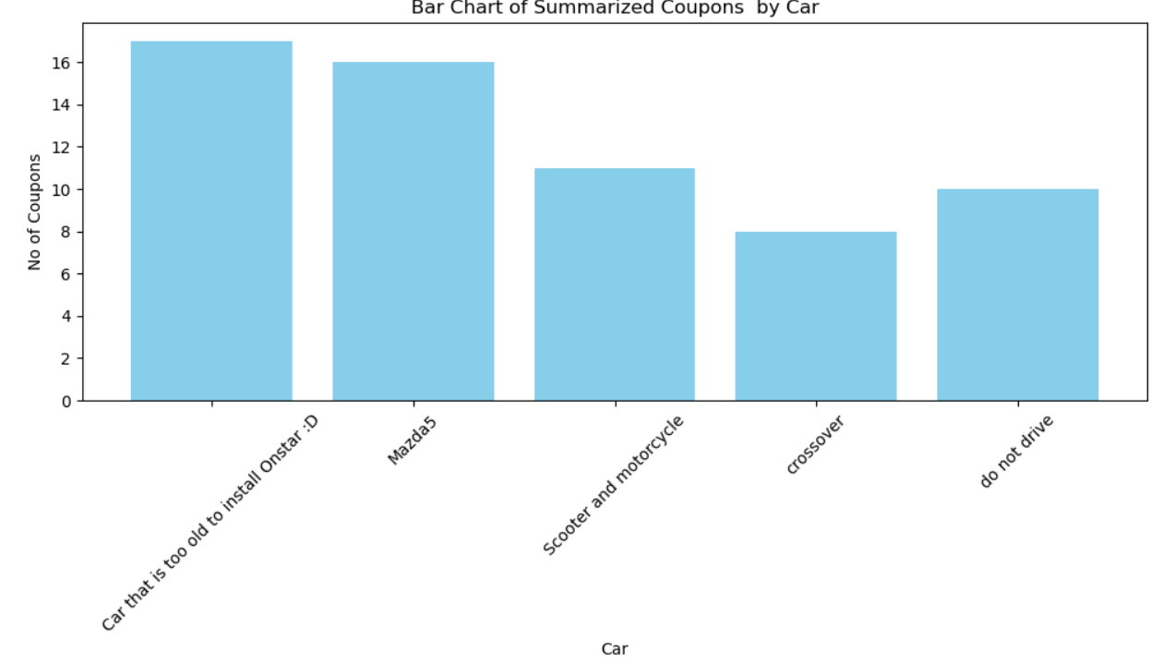

**Findings**

Based on the available data for Car Types , Members with Car types ‘Car that is too old to install Onstar’ or ‘Mazda5’ seem to have more in disposition for acceptance of coupons.

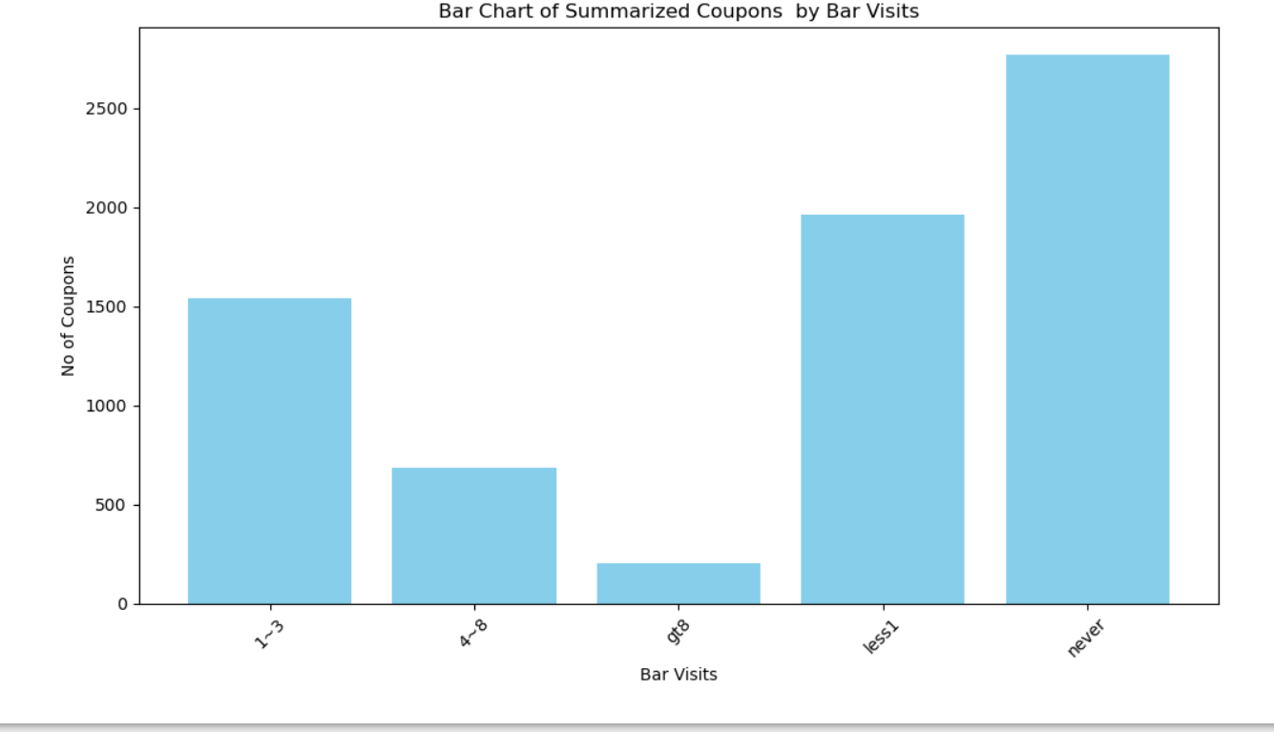

**Findings**

Based on the available data for Bar Visits , Members who have never visited a bar seem to be more in disposition for acceptance of coupons.

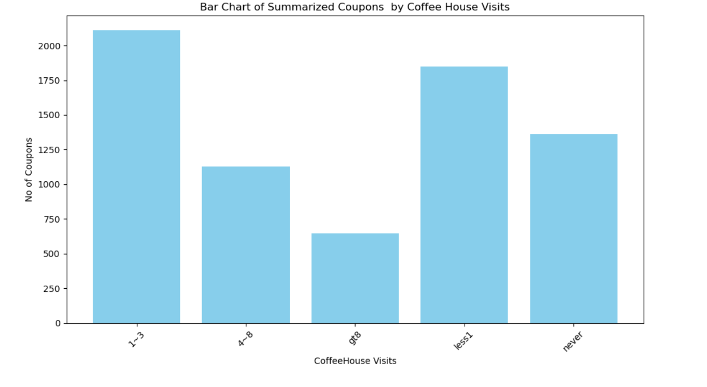

**Findings**

Based on the available data for Coffee House Visits , Members who have never visited a Coffee House or visited 1-3 times seem to be more in disposition for acceptance of coupons.

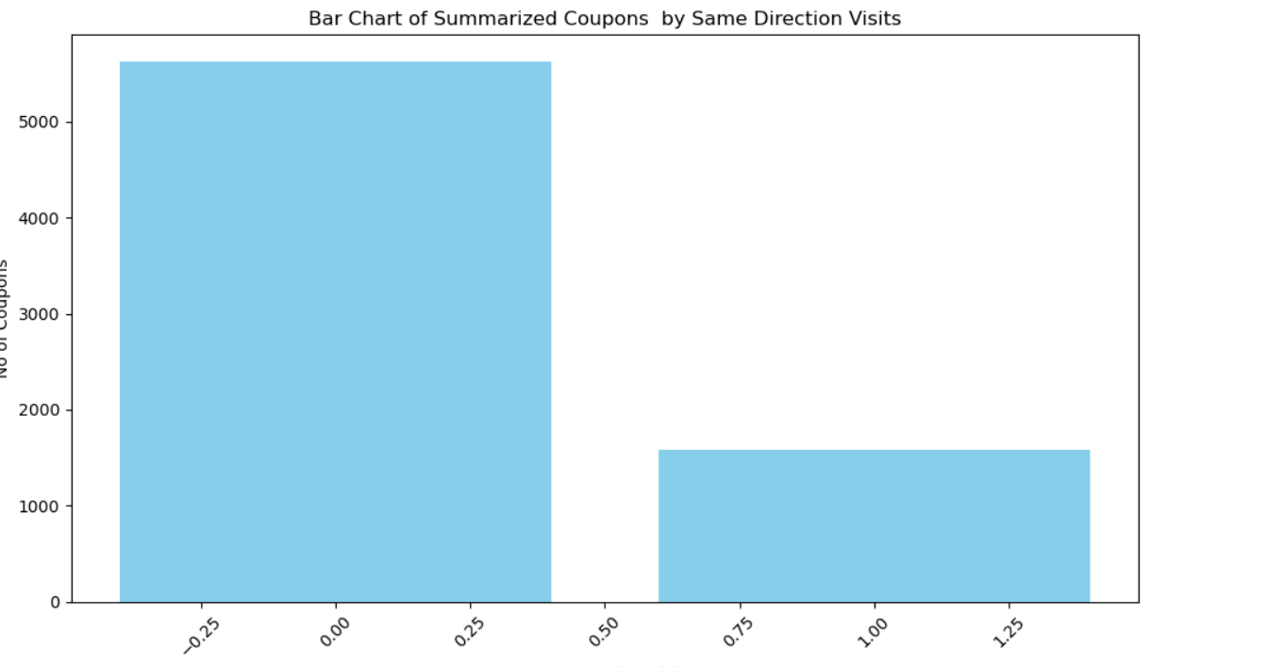

**Findings**

Based on the available data for ‘ Same Direction Visits ‘ , Members who are travelling in the same direction of the availability of coupons seem less likely to accept the coupons.

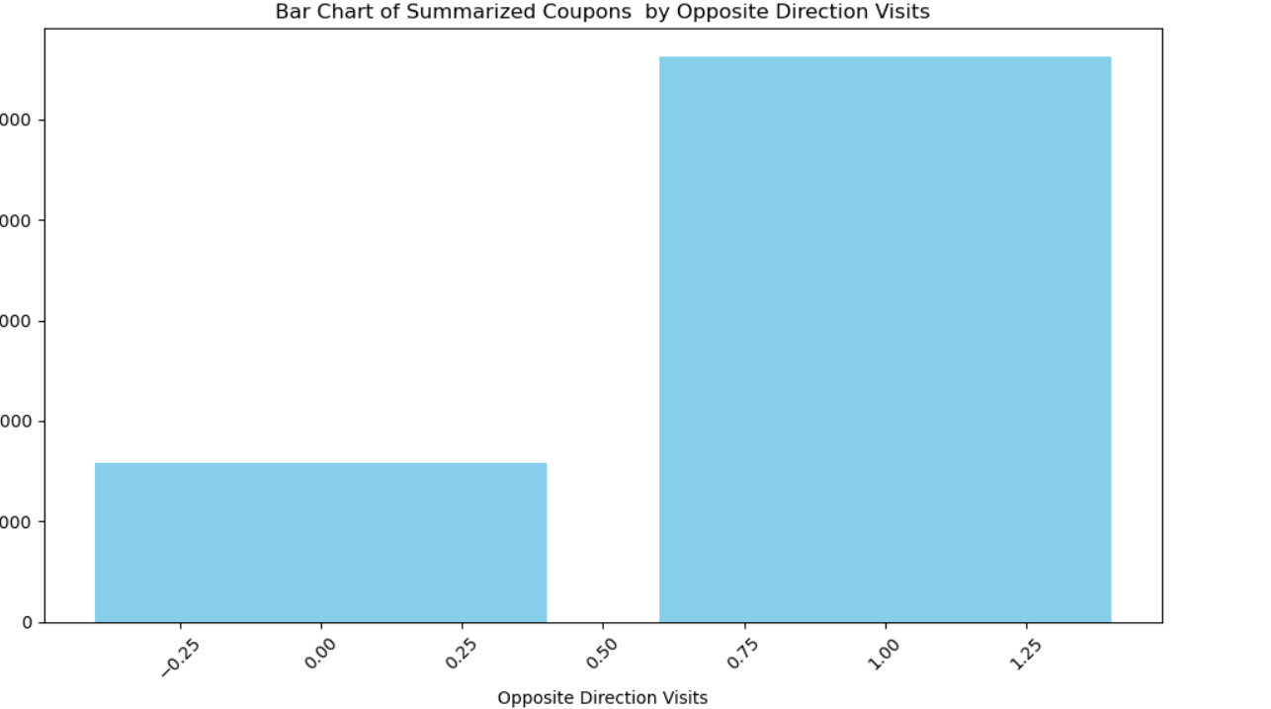

**Findings**

Based on the available data for ‘ Opposite Direction Visits ‘ , Members who are travelling in the Opposite direction of the availability of coupons seem more likely to accept the coupons 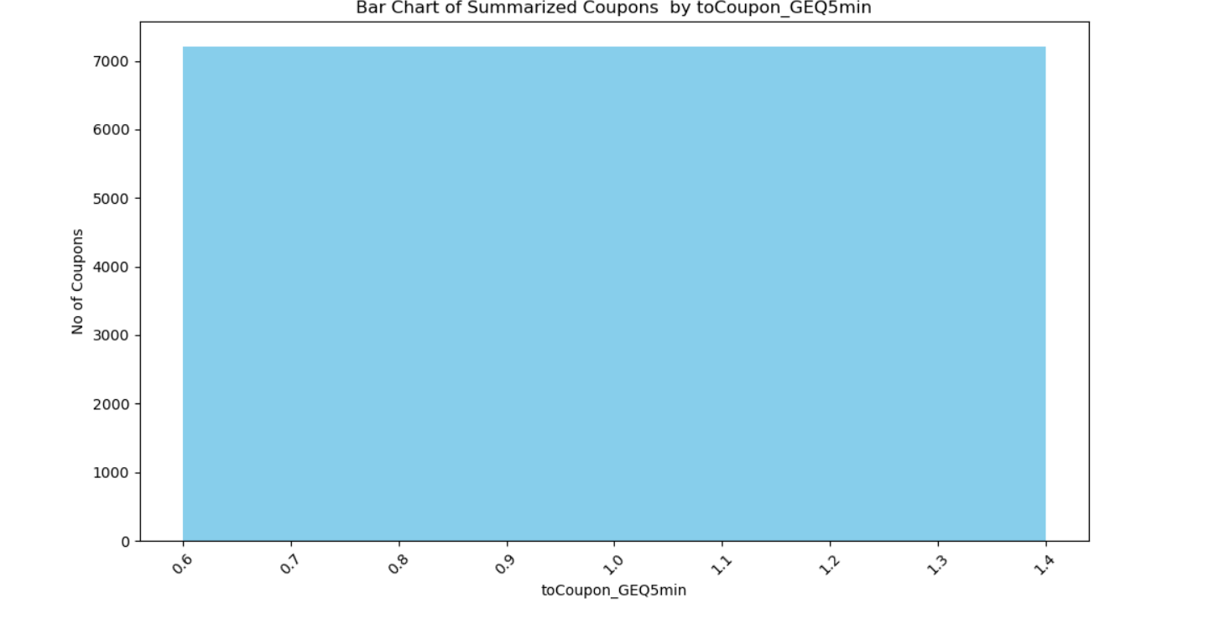

**Findings**

Based on the available data for ‘ Coupons that take 5 or more minutes to collect ‘ , Members are likely to accept these coupons all the time

. 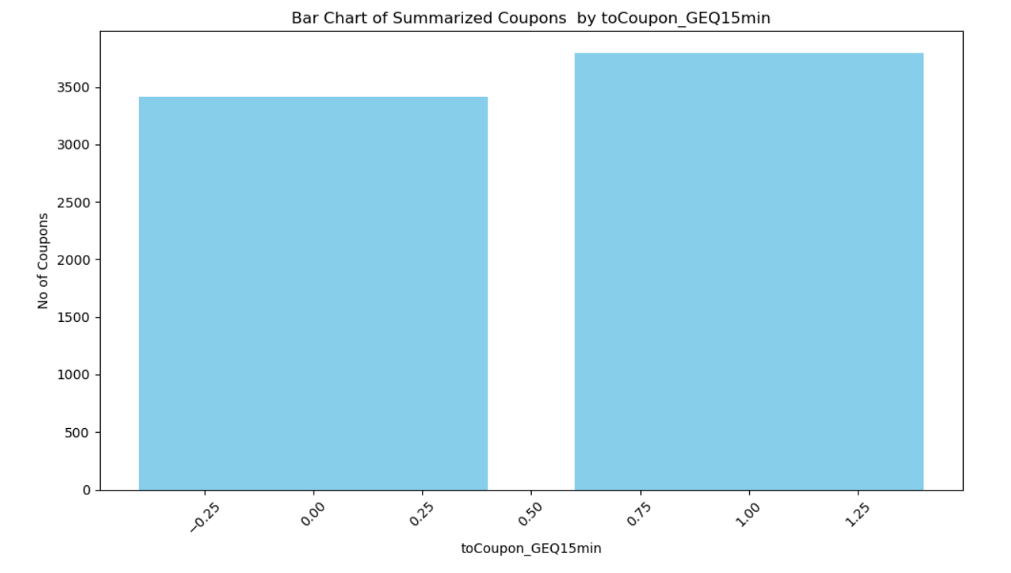

**Findings**

Based on the available data for ‘ Coupons that take 15 or more minutes to collect ‘ , Members are more likely to accept these coupons most of the time as seen in the above chart

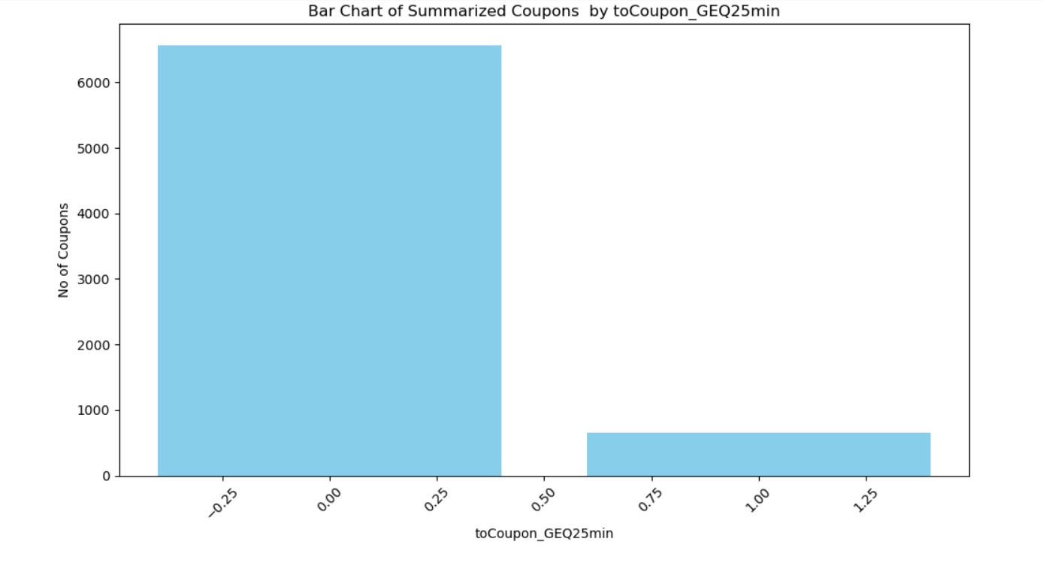

**Findings**

Based on the available data for ‘ Coupons that take 25 or more minutes to collect ‘ , Members are more likely to not accept these coupons most of the time as seen in the above chart

**Dimensions that could not be analyzed due to missing data:**

**The following dimensions could not be analyzed due to missing data**.

**A ticket was created with help desk to provide the data dictionary for the input file but they could not provide the same**. Request #2120541

1. **CarryAway**
2. **RestaurantLessThan20**
3. **Restaurant20To50**